# Suspension WIP

Last updated: 23/01/2017

2 programs used to iteratively optimis

e solution.

<http://www.vsusp.com/> (for geometry)

<http://suspensioncalculator.com/download.html> (for forces, moments and component selection)

## VSUP

Saving and Loading

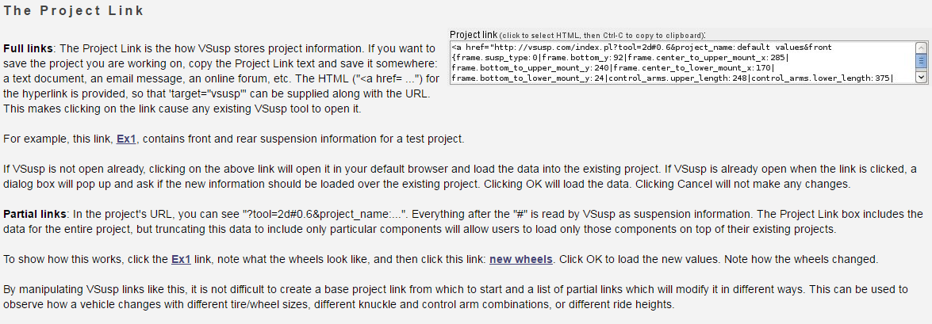

Saved Link

[url=http://vsusp.com/?tool=2d#0.8%26project_name%3ASalford%20mk.1%26trim%7Bbody_roll_angle%3A0%7Cfront.left_bump%3A0%7Crear.left_bump%3A0%7Cfront.right_bump%3A0%7Crear.right_bump%3A0%7D%26front%7Bframe.susp_type%3A0%7Cframe.bottom_y%3A7619%7Cframe.center_to_upper_mount_x%3A24079%7Cframe.bottom_to_upper_mount_y%3A20269%7Cframe.center_to_lower_mount_x%3A24079%7Cframe.bottom_to_lower_mount_y%3A0%7Ccontrol_arms.upper_length%3A24130%7Ccontrol_arms.lower_length%3A25400%7Cknuckles.hub_to_upper_x%3A15000%7Cknuckles.hub_to_lower_x%3A13000%7Cknuckles.hub_to_lower_y%3A13000%7Cknuckles.hub_to_upper_y%3A13000%7Cknuckles.hub_to_strut_axis%3A14000%7Cknuckles.strut_incl%3A8000%7Csteering.active%3A0%7Csteering.hub_to_outer_tie_rod_x%3A7620%7Csteering.hub_to_outer_tie_rod_y%3A7620%7Cwheels.offset%3A4000%7Cwheels.diameter%3A1300%7Cwheels.diameter_expl%3A35000%7Ctires.size_convention%3A0%7Ctires.section_width%3A20500%7Ctires.aspect_ratio%3A4000%7Ctires.diameter_expl%3A50000%7Ctires.width_expl%3A7620%7Ctires.compression%3A635%7D%26rear%7Bframe.susp_type%3A0%7Cframe.bottom_y%3A9200%7Cframe.center_to_upper_mount_x%3A28500%7Cframe.bottom_to_upper_mount_y%3A24000%7Cframe.center_to_lower_mount_x%3A17000%7Cframe.bottom_to_lower_mount_y%3A2400%7Ccontrol_arms.upper_length%3A24800%7Ccontrol_arms.lower_length%3A37500%7Cknuckles.hub_to_upper_x%3A15000%7Cknuckles.hub_to_lower_x%3A13000%7Cknuckles.hub_to_lower_y%3A13000%7Cknuckles.hub_to_upper_y%3A13000%7Cknuckles.hub_to_strut_axis%3A14000%7Cknuckles.strut_incl%3A8000%7Csteering.active%3A0%7Csteering.hub_to_outer_tie_rod_x%3A7620%7Csteering.hub_to_outer_tie_rod_y%3A7620%7Cwheels.offset%3A4000%7Cwheels.diameter%3A1500%7Cwheels.diameter_expl%3A35000%7Ctires.size_convention%3A0%7Ctires.section_width%3A19500%7Ctires.aspect_ratio%3A4500%7Ctires.diameter_expl%3A50000%7Ctires.width_expl%3A7620%7Ctires.compression%3A0%7D%26pref%7Bdiag1.px_per_mm%3A200%7Cdiag1.front_or_rear%3Afront%7Ctab.active%3A0%7Cunits%3A0%7Cshow.f%3A1%7Cshow.ca%3A1%7Cshow.k%3A1%7Cshow.st%3A1%7Cshow.stl%3A1%7Cshow.w%3A1%7Cshow.t%3A1%7Cshow.rc%3A1%7Cshow.rcl%3A1%7Cshow.ic%3A1%7Cshow.icl%3A1%7Cshow.fvsa%3A0%7Cshow.tl%3A0%7Cshow.kpil%3A0%7Credraw_during_drag%3A1%7Cchart.x_axis_center%3A0%7Cchart.x_axis_window%3A10%7Cchart.x_axis_num_steps%3A21%7Cchart.x_axis_field%3Atrim.body_roll_angle%7Cchart.y_axis_fields%3A%5BFR%5D.general.roll_center.y%7D]Salford mk.1[/url]

Current Frame Settings with 3 inch ground clearance.

